The Report of 4th Programming Homework

Implement the learning algorithms for perceptron in both original and dual form.

Test your program with the following training data:

$X_{1}={\left(3,3\right)}^{T}, y_{1}=1, x_{2}={\left(4,3\right)}^{T}, y_{2}=1, x_{3}={\left(1,1\right)}^{T}, y_{3}=0,$

And verify these data are linearly separable.

First, I plot the point and realize that we cannot separate those point in the form:

$$0=w_{1}x_{1}+w_{0}x_{0}$$

So we need an bias *b*.

***For the original form******, the training process are as follow:***

1. Initialize $w=[1,1]$ and b = 0
2. Select $\left(x_{i},y_{i}\right)$ from the training dataset
3. If $y_{i}\left(w∙x_{i}+b\right)≤0$

$$w←w+ηy_{i}x_{i}$$

$b←b+ηy_{i}$

1. Turn to step 2) until there is no miss classified

***Result:***

$w={\left(1,1\right)}^{T} , b=-4$

***For the dual form, , the training process are as follow:***

1. Initialize $α=0 and b=0$
2. Select $\left(x_{i},y_{i}\right)$ from the training dataset
3. If $y_{i}\left(\sum_{j=1}^{N}{α_{j}y_{j}x_{j}*x_{i}+b}\right)≤0$

$$α_{i}←a_{i}+η$$

$b←b+ηy_{i}$

1. Turn to step 2) until there is no miss classified

***Result:***

$$α={\left(2,0,5\right)}^{T},b=-3$$

$$w=\sum_{j=1}^{N}{α_{j}y_{j}x_{j}}=={\left(1,1\right)}^{T}$$

And at last we can get the figure:

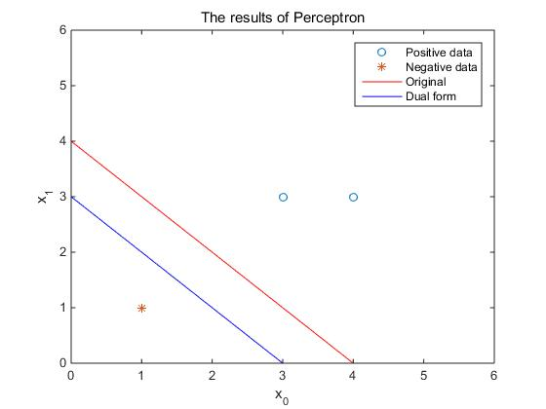

From the figure, the implement of perceptron learning algorithm in both original and dual form work well and training data is linearly separable.